QUESTION 4

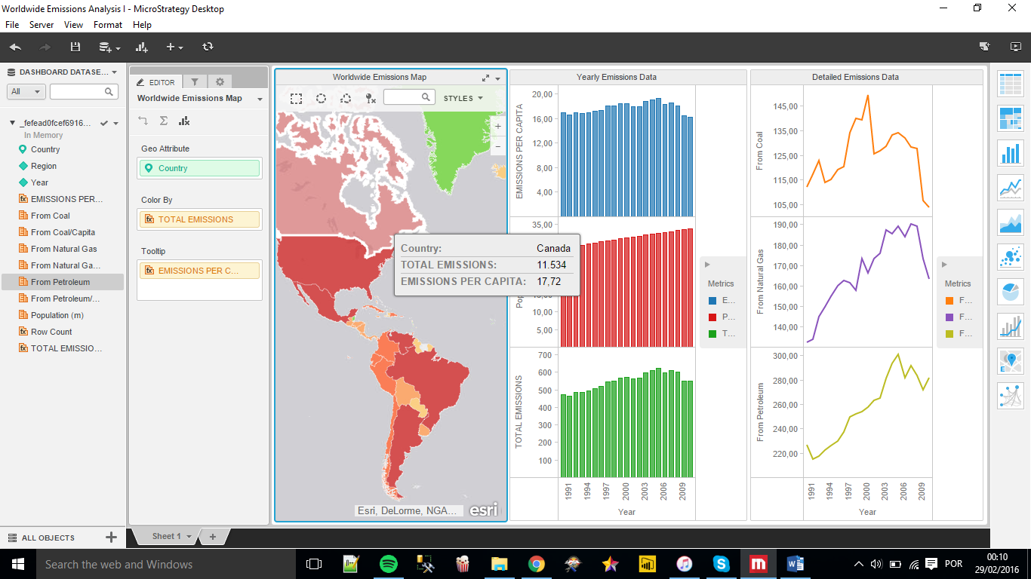1 What is the emissions per capita of Canada?  
17,72.

2 What is the overall trend in worldwide emissions?

The emission has increase so fast in the last decade, mainly when looking at the years between 2003 and 2006. However, from 2009 there was a decrease in usage of Natural Gas and Petroleum, maybe we are facing a big change related in the consumption of these materials, once there are a big investment in green energy.

Image bellow…

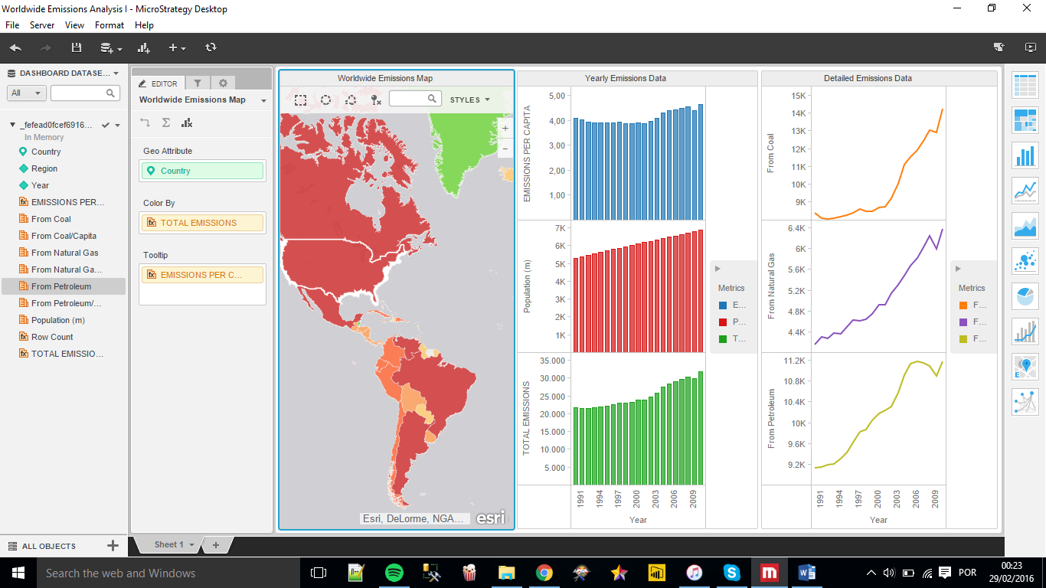

3 Notice that overall emissions declined in 2009, the only year in the total number of years surveyed that indicates emissions decreases in all three emissions sources. Why is that? What broader socio-political context might explain this single yearly decrease?

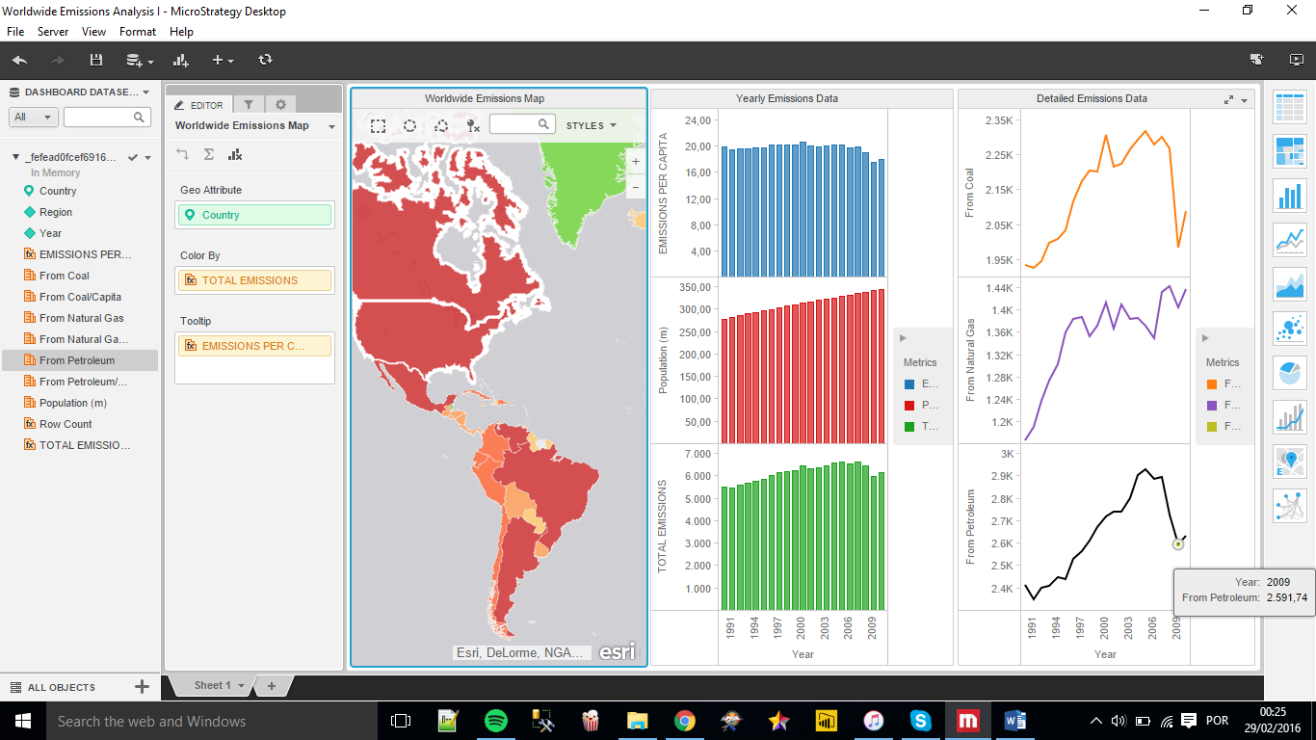There is a big chance of decline be related to the 2008 crisis, which has affected life of millions people, changing their habits of consumption in the biggest economy of the world.